**The sampling distribution of the difference in sample proportions**

* **E($\hat{p_{1}}-\hat{p_{2}}$) and Var $\left(\hat{p_{1}}-\hat{p_{2}}\right)$**

For a categorical variable, when __________________ with replacement from two _______________ populations with population proportion $p_{1}$ and $p_{2}$, the sampling distribution of the difference in sample proportions has mean $μ_{\hat{p_{1}}-\hat{p_{2}}}=___________$ and standard deviation $σ_{\hat{p_{1}}-\hat{p_{2}}}=$

_________________________

* If ________________, difference between sampling without replacement and sampling with replacement is negligible.
* **Determine whether a sampling distribution for $\hat{p_{1}}-\hat{p_{2}}$ can be modelled by normal distribution.**

If the sample size is large enough:

the sampling distribution of $\hat{p_{1}}-\hat{p_{2}}$ will have an approximate normal distribution.

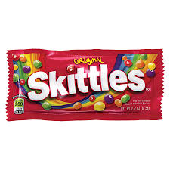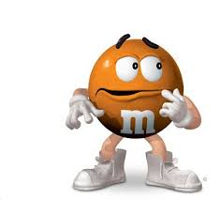

Mr. Wilcox believes that Skittles have a higher proportion of orange candies than M&Ms, while Mrs. Gallas believes the opposite. Who is correct?

A Google search reveals that 21.6% of Skittles are orange and 20% of M&Ms are orange.

1. Describe the sampling distribution of the sample proportion of orange for Skittles ($\hat{p_{S}}$) and the sampling distribution of the sample proportion of orange for M&Ms ($\hat{p_{O}}$) for samples of size 50.

|  |  |  |
| --- | --- | --- |
|  | Skittles ($\hat{p_{S}}$) | M&Ms ($\hat{p_{O}}$) |
| Shape: |  |  |
| Mean: |  |  |
| SD: |  |  |

1. Describe the sampling distribution of the difference between proportions of orange Skittles and M&Ms ( $\hat{p_{S}}$*– $\hat{p_{O}}$* ).

Shape:

Mean of difference between proportions:

Standard deviation of the difference between proportions:

1. Mr. Wilcox and Mrs. Gallas calculated a difference between proportions of 0.08 from their samples. Calculate the probability of getting this difference in proportions or higher.

Practice 1:

According to the American Dental Association, 8% of adults have never had a cavity. A dental graduate student contacts an SRS of 1000 adults and calculates the proportion $\hat{p}$ in this sample who have never had a cavity.

1. Identify the mean of the sampling distribution of $\hat{p}$.
2. Calculate and **interpret** the standard deviation of the sampling distribution of $\hat{p}$. Check that the 10% condition is met.
3. Is the sampling distribution of $\hat{p}$ approximately Normal?
4. Find the probability that the random sample of 1000 adults will give a result within 2 percentage points of the true value.
5. If the sample size were 9000 rather than 1000, how would this change the sampling distribution of $\hat{p}$?

Practice 2:

At Westville High School there are 315 seniors and 389 juniors. 65% of the seniors have parking passes and 42% of the juniors have parking passes. The statistics teacher selects a SRS of 30 seniors and a separate SRS of 30 juniors. Let ${\hat{p}}_{S}-{\hat{p}}_{J}$ be the difference in the sample proportions of seniors and juniors that have parking passes.

1. What is the shape of the sampling distribution of ${\hat{p}}_{S}-{\hat{p}}_{J}$? Why?
2. Find the mean of the sampling distribution.
3. Calculate and **interpret** the standard deviation of the sampling distribution.
4. What is the probability that the difference in sample proportions (senior – junior) of students with parking passes is greater than 30%?